WSUD Maintenance cost survey
1 Overview 1
2 What we’re asking from you 2
3 Maintenance definitions 2
3.1 Routine maintenance 2
3.2 Corrective maintenance 2
3.3 Not required 3
4 Data standards 3
5 How to enter data 3
6 FAQs 3
7 Questions/ concerns 4

Overview
Water by Design is undertaking a project to collect, analyse and publish updated WSUD maintenance cost data to support councils and asset owners across Australia.
Updated maintenance data is critically needed. The most recent data collection effort was completed in 2020 and costs are likely to have changed significantly since that time.
Likely outputs of this work include:
- A WSUD maintenance cost fact sheet similar to one published by Melbourne Water in 2013 (Figure 1), but with a primary focus on maintenance costs rather that broader lifecycle costs.
- A background report summarising methods and analysis.
The project is proudly funded by the Queensland Government’s Water Quality Investment Program, delivered by the Department of the Environment, Tourism, Science and Innovation.
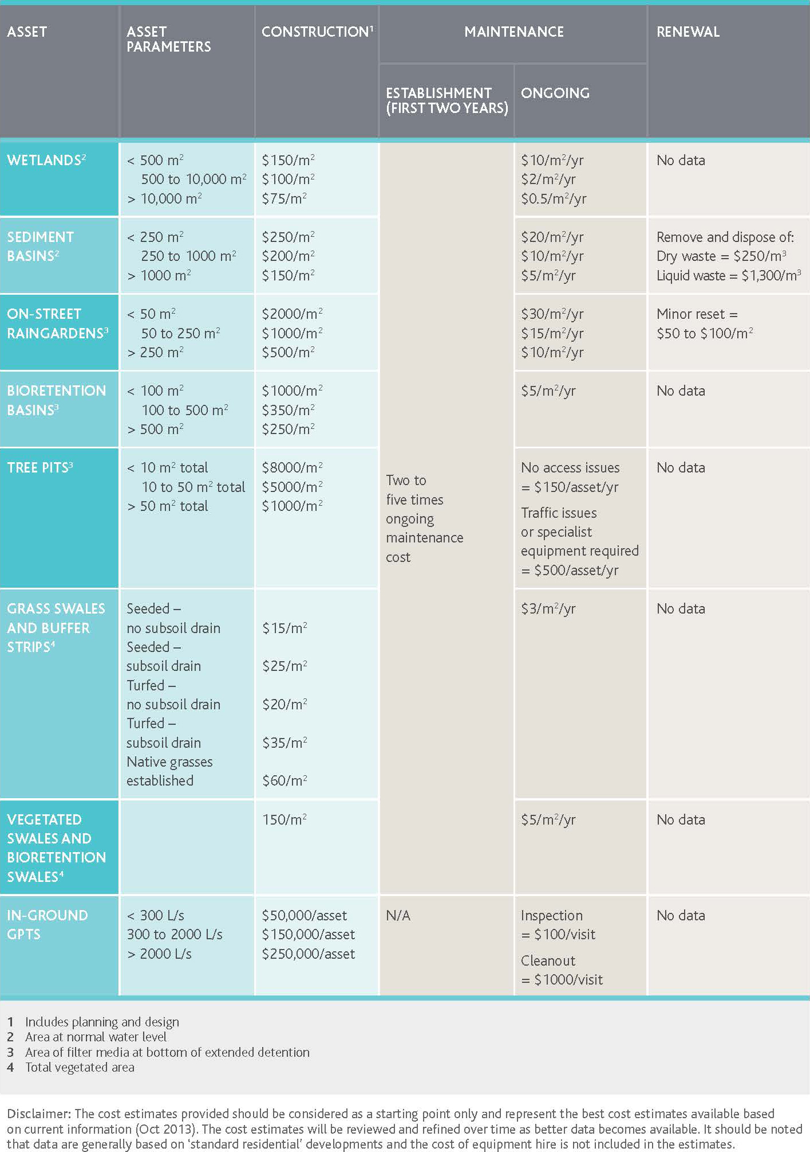
Figure 1. Except from the Melbourne Water WSUD Lifecycle Cost fact sheet published in 2013.

What we’re asking from you
We are seeking any and all data relating to the cost of maintaining WSUD assets such as bioretention systems, constructed wetlands, swales, gross pollutant traps, etc.
The focus is maintenance only (routine and corrective), and not design, construction, renewal or decommissioning costs. However, if you happen to hold lifecycle data (construction/renewal), feel free to share it – this is optional but may help strengthen the analysis.
To provide data, please complete the attached Excel workbook:
- You may provide data on an asset by asset basis, or lumped data for multiple assets.
- The minimum data needed per row is:
  - Asset name/ID (for lumped data, simply state that it is lumped).
  - Asset type.
  - Asset size (for lumped data, provide the total asset size and number of assets).
  - Maintenance type (routine or corrective).
  - Frequency.
  - Cost (per year).
  - Notes (if needed).
- You may duplicate the asset across rows as long as each row is a different maintenance type or a distinct corrective activity you’d like to record.
Data on any number of assets is welcome.

Maintenance definitions

Routine maintenance
Regular, scheduled tasks required to keep an asset performing as intended.
Examples:
- Litter and debris removal.
- Weed control.
- Vegetation trimming / mowing.
- Forebay sediment skimming.
- GPT cleanouts.
- Inspections and reporting.
- Waste disposal and admin/overheads.

Corrective maintenance
Infrequent interventions to restore function when routine tasks are no longer sufficient.
Examples:
- Filter media replacement in bioretention.
- Vegetation renewal.
- Erosion / scour repair.
- Replacing GPT screens.
- Regrading wetland macrophyte zones.
- Inlet / outlet repairs.

Not required
- Decommissioning.
- Major renewals.
- Capital upgrades.
- Full reconstructions.

Data standards
- Use AUD, ex. GST for all costs.
- Routine frequency = visits per year
- Corrective frequency = years between events
- Area: m² (bioretention, wetlands, ponds, sedimentation basins)
- Length: m (swales)
- Volume (if used): m³
- Dates: Year only (YYYY) for “Year constructed/commissioned”. If unsure how to classify a task, add a note – we will normalise these during analysis.
- Indicate in “Notes” whether routine costs include overheads (admin, mobilisation, travel, waste). If they don’t, briefly list what’s excluded.
The glossary in Tabs 2 and 3 provides standardised definitions for asset and maintenance types.

How to enter data
- Read Tab 2 – Asset types and Tab 3 – Maintenance types to align on definitions.
- Go to Tab 4 – WSUD assets (data entry).
- Enter one row per maintenance type.
  - If an asset has both routine and corrective maintenance, create two or more rows with the same Asset name/ID.
  - If you want to capture multiple distinct corrective events (e.g. different scopes or intervals), you may add additional corrective rows – use the “Notes” field to clarify.
- Enter costs ex. GST (AUD).
- Use the correct units for asset size (m² for basins/wetlands/bioretention, m for swales, volumes in m³ if used).
- Provide notes for anything unusual (e.g. difficult access, traffic management, vandalism, steep batters, high weed pressure).

FAQs
Q1. We track a combined routine contract (multiple tasks in one visit). How should we enter this?
Enter the total cost per year and the number of visits per year. Use “Notes” to list typical tasks.
Q2. We replaced media once in 2018 but don’t have a standard interval. How should we enter this?
Enter the event cost and your best estimate of interval (e.g. for 8 – 12 years, use 10 years), and note the uncertainty.
Q3. Our proprietary device has contractor bundled pricing with waste disposal. How should we enter this?
Enter the bundled cost and clarify inclusions in “Notes”. No brand names required – describe the function (e.g. “cartridge filter vault”).
Q4. Can we provide only a subset of assets?
Yes. Even a handful of well‑documented assets is valuable.

Questions / concerns
We want to make the process of providing data as simple as possible. If you have any questions or concerns, please reach out to jack.m@hlw.org.au.

